Pedagogical Lexicon

What is Pedagogical Lexicon
# Source: AI Source: Provided by: [Data Path: Persons Table -> ID Column: 1, Name_En Column: Motasem Essam] -> From: [Chatgpt (GPT-4-turbo)] on [7/29/2025]
A Pedagogical Lexicon is a curated set of vocabulary specifically selected for language learning and teaching. It focuses on high-frequency, high-utility words and phrases that help learners acquire functional and communicative competence in a new language.

🔹 Key Features of a Pedagogical Lexicon
# Source: AI Source: Provided by: [Data Path: Persons Table -> ID Column: 1, Name_En Column: Motasem Essam] -> From: [Chatgpt (GPT-4-turbo)] on [7/29/2025]
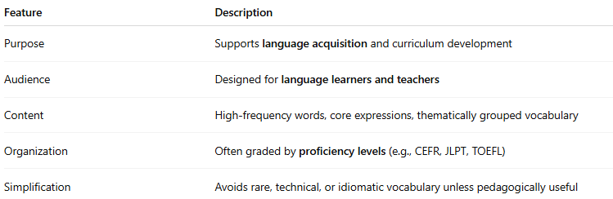

Feature | Description
Purpose | Supports language acquisition and curriculum development
Audience | Designed for language learners and teachers
Content | High-frequency words, core expressions, thematically grouped vocabulary
Organization | Often graded by proficiency levels (e.g., CEFR, JLPT, TOEFL)
Simplification | Avoids rare, technical, or idiomatic vocabulary unless pedagogically useful

🔹 What It Includes
# Source: AI Source: Provided by: [Data Path: Persons Table -> ID Column: 1, Name_En Column: Motasem Essam] -> From: [Chatgpt (GPT-4-turbo)] on [7/29/2025]
- Basic vocabulary: book, walk, water, school
- Function words: and, if, because, who
- Phrasal verbs and expressions: get up, take off, look after
- Themewise organization: food, colors, daily activities
- Graded by levels:
  - CEFR A1–C2 (e.g., CEFR Vocabulary Profiles)
  - NGSL (New General Service List)
  - GSL (General Service List)
  - Academic Word List (AWL)

🔹 Examples of Pedagogical Lexicons
# Source: AI Source: Provided by: [Data Path: Persons Table -> ID Column: 1, Name_En Column: Motasem Essam] -> From: [Chatgpt (GPT-4-turbo)] on [7/29/2025]
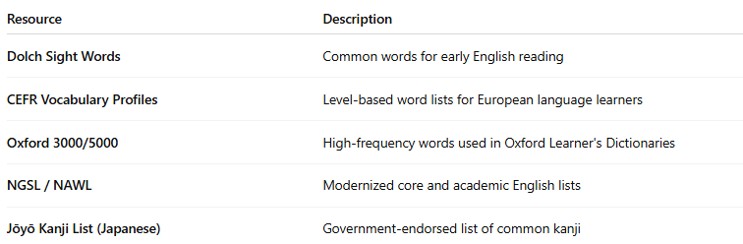
Resource | Description
Dolch Sight Words | Common words for early English reading
CEFR Vocabulary Profiles | Level-based word lists for European language learners
Oxford 3000/5000 | High-frequency words used in Oxford Learner's Dictionaries
NGSL / NAWL | Modernized core and academic English lists
Jōyō Kanji List (Japanese) | Government-endorsed list of common kanji

🔹 Pedagogical vs General Lexicon
# Source: AI Source: Provided by: [Data Path: Persons Table -> ID Column: 1, Name_En Column: Motasem Essam] -> From: [Chatgpt (GPT-4-turbo)] on [7/29/2025]
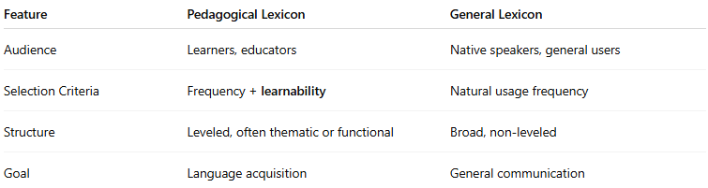
Feature | Pedagogical Lexicon | General Lexicon
Audience | Learners, educators | Native speakers, general users
Selection Criteria | Frequency + learnability | Natural usage frequency
Structure | Leveled, often thematic or functional | Broad, non-leveled
Goal | Language acquisition | General communication

